Hart House Underwater Club: Activating an eLearning code in NAUI CORE.

- Visit https://core.naui.org/signin

- Create a new online account with NAUI.

- NAUI will send you a registration confirmation and invitation to complete your CORE setup.

- Log-in and complete the profile setup. Please ensure accurate information as this will be used to verify your SCUBA certifications.

- On the left menu panel, click “My courses”
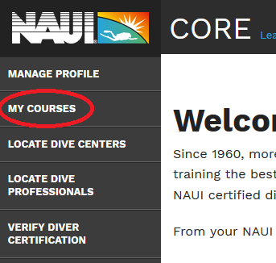

- Click the button “Activate a NAUI Education System” in My Courses.

- Enter the 10 or 32 character e-learning code provided by your Instructor.

  - “Find”
  - “Activate this education system”
  - NAUI Trainer / Instructor: ____________________, NAUI# ______
OR
  - NAUI Store / Dive Centre: Hart House Underwater Club, CAP01445

You should be now able to start eLearning. Have fun!

